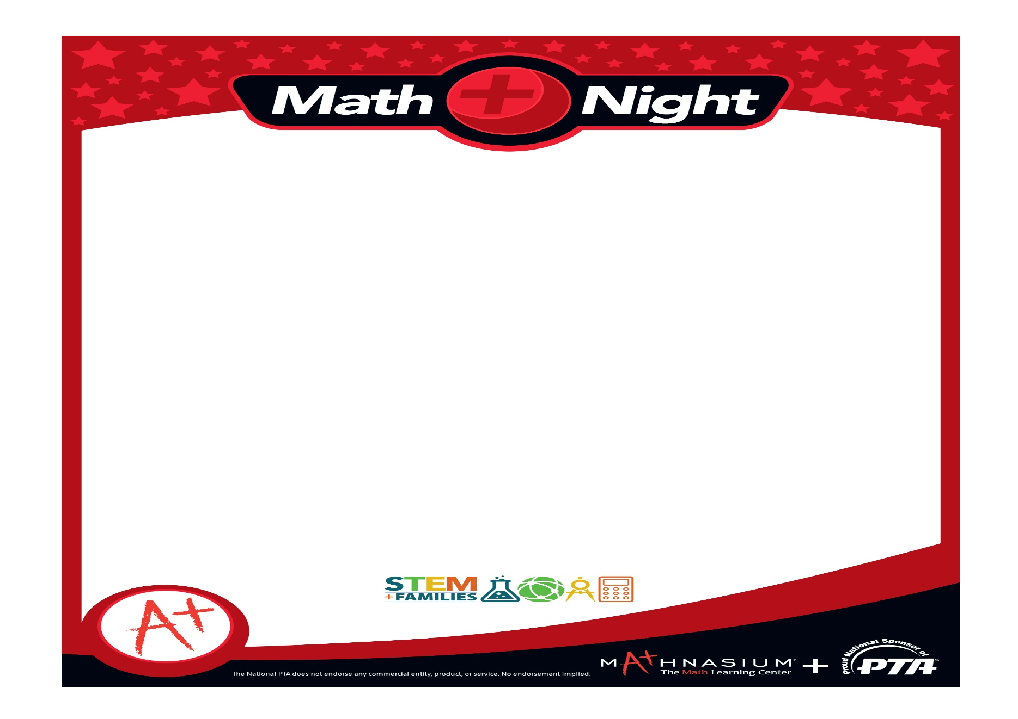

At Mathnasium Math Night, you and your kids will roam from table to table in the Fernbank cafeteria to play various fun math games together, led by Mathnasium staff members and volunteers. **Get your Math Night "passport" stamped at each game station to be eligible for the following raffle prizes at the end of the night!**

1)  Parents Raffle for a 3-month membership to Mathnasium for interested parents who are new to Mathnasium. 3 runner-ups will also receive one-month memberships -- *Over $2,000 in Mathnasium services!  **Intended for new Mathnasium members only*

*2)* All parent attendees who sign in at Math Night may receive a free assessment and free registration at Mathnasium \*\**$149 value, must schedule assessment with Mathnasium by March 15, 2018!*

*3)*Enrolled Mathnasium parents only may enter a separate raffle.  Winner and runner-up prizes: $250 gift card, $200 gift card, and $150 gift card (either Visa or Amazon-- parents' choice!)

4)  Tonchu Martial Arts Raffle for a 6-month membership-- *Over $1,000 in value; **Intended for new Tonchu members only*

5)  Kids who play all the games at Math Night may choose to enter one of many separate raffles for a toy (or bundle of toys) of his/her choice! *Over $500 in toys will be given away to kids who attend!*

Sample items include: Amazon Kindle Tablet (2), Amazon gift cards, Batman Drone, Remote Control Flying Shark, BB8 Robot, MiP coding robot, kid's baking set, Beanie Boos, math games, board games, other gift cards, and more!

**ALL RAFFLE WINNERS ANNOUNCED THE DAY AFTER MATH NIGHT!**

6)  **Enrolled Mathnasium students will receive 1 completed Mathnasium punch card (for use at the Mathnasium reward cabinet at our center) just for showing up to Math Night.  Also, enrolled kids will receive 3 competed punch cards for each Fernbank student that they bring as their guest to math night.  \**\*Kids must report their friends at check-in to get punch cards, Enrolled kids get cards for up to 3 invited guests*

7)  **Free goody bags for all kids

***\*\*Please RSVP*** [**here**](https://docs.google.com/forms/d/e/1FAIpQLSeEGURBOueCGLxc9snRmKJHZr9BDJ6qcKnh8sqCQyq02B9A-w/viewform) ***so we know how many kids to expect!***

**Thursday, February 1st, 6pm, Fernbank Cafeteria**